
Winter Sem 2025-26
Project Report
Smart Study Planner using Machine Learning

Name – Kriti Kaushik
Registration Number – 25BCE10110
Subject Code – CSA2001
Course - Fundamentals of AI and ML
Faculty Name - Satyendra Singh
Slot - B21+E14+E22

INTRODUCTION

In today’s academic life, students often struggle with managing time, meeting deadlines, and maintaining productivity. This project presents a Smart Study Planner that uses Machine Learning to help students organize their study schedules efficiently and predict the time required to complete tasks. The system predicts the time required to complete study tasks based on factors like subject difficulty and study hours. It then provides suggestions to help students organize their daily study routine.
This project demonstrates how basic Machine Learning concepts can be applied to solve everyday problems in education.

- Problem Statement – Time management is a common issue among students. Many students:
- Underestimate or overestimate study time
- Fail to prioritize subjects
- Feel overwhelmed due to poor planning
- There is no simple tool that helps students:
- Predict how much time they need for a subject
- Plan their study schedule accordingly
- This project aims to solve this problem by developing a system that predicts study time and provides a simple study plan using Machine Learning.

OBJECTIVE

- The main objectives of this project are:
- To develop a system that helps students plan their study schedule
- To predict study completion time using Machine Learning
- To improve productivity and reduce academic stress
- To demonstrate the use of AI/ML in real-life applications

REAL-WORLD RELEVANCE

- This problem is commonly observed in:

- Schools and colleges
- Competitive exam preparation
- Online learning platforms

- A smart planner can:

- Improve learning efficiency
- Reduce last-minute stress
- Help in better time utilization

METHODOLOGY

Data Collection
A simple dataset is created manually with:
- Difficulty level (1–5)
- Study hours
- Completion time
Data Preprocessing
- Data is organized in structured format
- No missing values
- Clean and simple dataset
Model Selection
Linear Regression is used because:
- It is simple and beginner-friendly
- Works well for predicting continuous values
Model Training
The model is trained using:
- Input: difficulty + hours studied
- Output: completion time
Prediction
User inputs values → model predicts required study time

MY APPROACH TO SOLVING THE PROBLEM

- To solve the problem of poor time management among students, I followed a step-by-step approach.
- First, I identified that students often cannot estimate how much time a subject will take. So, I decided to build a system that can predict study time based on simple inputs like subject difficulty and study hours.
- Next, I collected a small dataset that represents study patterns. Since this is a beginner-level project, I created a simple dataset instead of using a complex real-world dataset.
- After that, I selected a Machine Learning algorithm. I chose Linear Regression because it is easy to understand and suitable for predicting continuous values like time.
- Then, I trained the model using the dataset so that it could learn the relationship between difficulty, study hours, and completion time.
- Finally, I added a simple decision-making system (AI logic) that gives suggestions like whether the subject is easy, moderate, or difficult based on the predicted time.
This step-by-step approach helped in building a simple but effective study planner system.

Implementation

Tools Used:
1. Python
- Main programming language used
- Easy and beginner-friendly
2. Scikit-learn
- Library used for Machine Learning
- Provides Linear Regression model
3. Linear Regression
- ML algorithm used to predict study time
- Works for continuous values

Steps:
- Import libraries
- Create dataset
- Train model
- Take user input
- Predict output

CHALLENGES FACED
- Small dataset
- Limited accuracy
- Handling different subjects

KEY DECISIONS I MADE
While developing this project, I made several important decisions:
- I chose a real-life problem (student time management) so that the project is practical and meaningful
- I selected Linear Regression as the algorithm because it is simple and beginner-friendly
- I decided to use a small and simple dataset to keep the project easy to understand
- I combined Machine Learning (prediction) with Artificial Intelligence (decision-making) to make the system more useful
- I kept the code simple and readable so that it is easy to explain and modify
- I avoided complex tools and focused on basic implementation to match my current learning level
- I added user input feature to make the project interactive
These decisions helped in completing the project successfully while keeping it simple, clear, and aligned with course concepts.

LIMITATIONS
- Not highly accurate
- Works on small data
- Does not consider external factors (mood, distractions)

WHAT I LEARNED

- Through this project, I learned many important concepts related to AI, ML, and programming:
- I understood the basic difference between Artificial Intelligence and Machine Learning
- I learned how Machine Learning models are trained using data
- I gained knowledge about Linear Regression and how it is used for prediction
- I learned how to take user input and process it in Python
- I understood how to combine ML prediction with AI-based decision making
- I improved my problem-solving and logical thinking skills
- I learned how to structure a complete project including code, report, and documentation
- I understood the importance of real-world applications of AI in education
This project helped me build a strong foundation in AI and ML and gave me confidence to work on more advanced projects in the future.

CODE SCREENSHOT

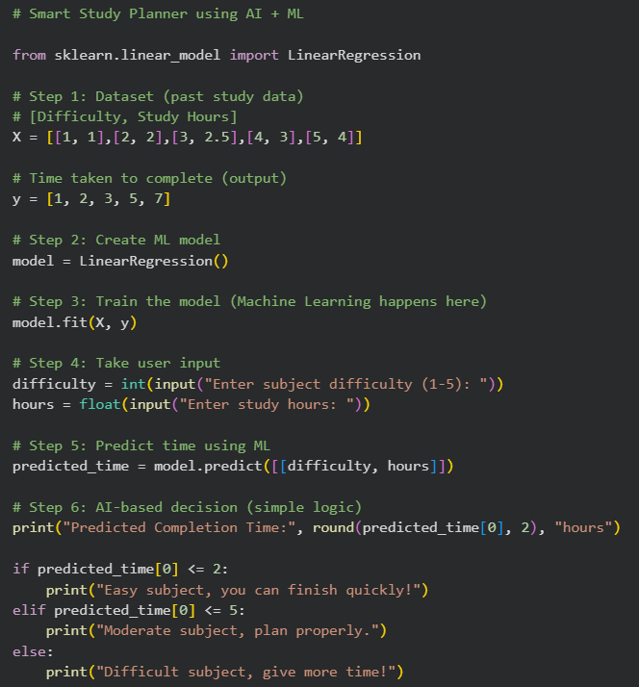

CODE OUTPUT

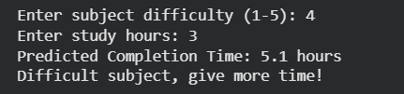
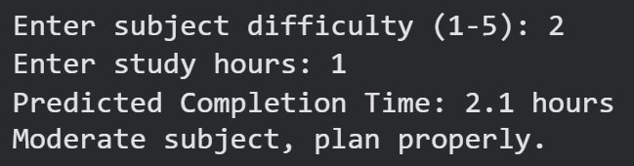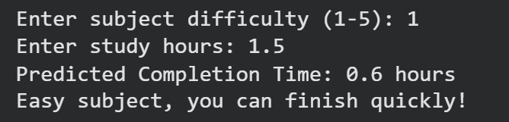

CODE EXPLANATION

Step 1: Dataset Creation
X = [[1,1], [2,2], [3,2.5], [4,3], [5,4]]
y = [1,2,3,5,7]
- X = input data (difficulty + hours)
- y = output (completion time)

Step 2: Model Creation
model = LinearRegression()
- Creates ML model
- This model will learn from data

Step 3: Model Training
model.fit(X, y)
- The most important step
- Model learns relationship between input and output
- This is where Machine Learning happens

Step 4: User Input
difficulty = int(input(...))
hours = float(input(...))
- Takes values from user

Step 5: Prediction
predicted_time = model.predict([[difficulty, hours]])
- Model predicts study time
- Uses learned data

Step 6: AI Decision Logic
if predicted_time[0] <= 2:
- This is Artificial Intelligence part
- System makes decision:
  - Easy
  - Moderate
  - Difficult

